Introduction This paper will analyze athletic clothing retailer, Lululemon Athletica. Although Lululemon currently does not have a storefront in State College or any of the immediate surrounding areas, this paper will support, with logic learned from Marketing 437, why Lululemon would be successful and should be opened in State College, Pa. I will briefly introduce Lululemon and its history, and discuss the five main elements of the retail mix. Included at the end of this paper are pictures, listed as addendums. These are only included for enhancement because of lack of familiarity with the company. Lululemon is an athletic apparel retailer that not only sells clothing, but a lifestyle. The clothing is high-quality performance wear. Catered largely towards fashion focused, athletic women, the clothing is made is such a way as to keep consumers comfortable while working out, but stylish after as well. The clothing is mainly marketed to participants of yoga, running, and tennis but can be worn to participate in any sport. History Lululemon is a Canadian headquartered yoga-inspired apparel company. Founded in 1998 by Chip Wilson, the first store open in Kitsilano—a small beach town in Vancouver British Columbia. Wilson began Lululemon shortly after his first time practicing yoga. He was fond of the feeling yoga gave him, but unhappy with the cotton based clothing he would wear to practice in, feeling sweaty and uncomfortable. Wilson started a design studio, and used it as a yoga studio at night to pay for the rent expense. He got feedback on his products from yoga participants and instructors. Wilson believed in women participation in sports, and saw the creation of Lululemon as a way to enter the athletically, stylish women market. The company is heavily focused on promoting a healthy lifestyle and mindset. Image The mission statement of Lululemon is called ‘their manifesto’: “provide components for people to live a longer, healthier and more fun life.” Their company goal is “to elevate the world from mediocrity to a place of greatness.” These manifestos help to paint the picture of Lululemon’s image. Yoga is increasingly becoming trendier throughout the US, with their target market largely female focused. When you purchase Lululemon products, you buy into the lifestyle of the products. Whether you wear the apparel for fitness purposes or going on errands, the look of the product reflects the image that you are athletically fit and stylish. Such examples of this image are reflected in the names of their products like the “Don't Hurry Be Happy Pullover”, “Groove Pant” or the “What the fluff” product line. The image is also displayed through that high quality of the products and innovation. For example, all products in the “What the fluff” product line boast new technology, incorporating warm down fill feathers as well as ventilation for colder workouts. The store fronts serve as a meeting place where clientele can come to explore, discuss and learn about products, new workout tips, and talk to others leading athletic lifestyles. The location heavily corresponds to their promotion strategy and reputation. Storefronts are used to help spread their main marketing strategy: grassroots marketing. Store employees are known as ‘educators’ and are there to promote the manifesto and provide excellent customer service. The stores each cater large special event promotions, hosting free yoga session in the stores, parks and communities they operate in. The nine attributes of image will be further elaborated and compared to Penn State throughout this paper. Target market and position The target consumer of Lululemon is women- primarily affluent 18 to 34-year-olds. These females are health conscious and have an interest in fashion but a need for performance clothing. They care about fit and comfort, while incorporating both function and style. The company said in their annual report “our primary target customer is a sophisticated and educated woman who understands the importance of an active, healthy lifestyle. She is increasingly tasked with the dual responsibilities of career and family and is constantly challenged to balance her work, life and health. We believe she pursues exercise to achieve physical fitness and inner peace.” Penn State females fit this mold. There are 17,920 undergraduate and 4,062 graduate female students at University Park. These women are pursuing their education, trying to better themselves and prepare for their future. This is in line with Lululemon; a company that preaches goal setting and continually improving one’s self. More so, Penn State females have a large emphasis on body image and hold importance on being healthy and fit. University Park’s campus has three main gyms: the white building with capacity of 210 students, Intramural building with capacity of 60 students, and Recreation Hall with capacity of 240 students. These gyms are always flooded with students. Penn State also charges students for gym memberships, at approximately $54 a semester. The choice to purchase a membership, which many students do, shows student’s desire to live a healthy lifestyle, which fits Lululemon’s image. More so Lululemon understands their customers walk around in exercise clothes much of the day and still want to look and feel good in what they are wearing, whether they are exercising, practicing yoga, or not. This is supportive of college students at Penn State. Students are always on the move, going from class to the gym, on a run, on errands or to meetings. The products and image support ‘on the go’ females and can be worn both during physical activity, to class, or to give the allusion of being physically fit and stylish. Although college aged students typically do not have large disposable incomes, they still able to purchase the high quality, premium priced clothing through discretionary income earned from various jobs (summer and during the year) or parental support. The brand is positioned as high quality and exclusive. Lululemon is in the process of further expanding its male market, which I also see as a reason to enter Penn State’s market. The store would gain the interest of athletic males who see the store positioned as healthy and innovative. Both female and male students value quality and innovation, which the store will be seen as. Special considerations The store’s location for Lululemon is as important as the products themselves. As mentioned, Lululemon is all about promoting a healthy lifestyle and mindset. They call their employee’s educators and host promotional events often in the communities they operate. The store’s layout is free form and constantly changing; products are visually shown on manikins, elevated on top of bins. The bins organize the product via size. Given that the products are often tight fighting, the visual presentation allows customers to see the product and easily grab their size (addendum #1). They can then try on the clothing in the store, and get assistance from the educators. The store even offers tailoring, but this topic will be further elaborated in customer service. There are currently six stores operating in Pennsylvania, mainly in Philadelphia and Pittsburgh, so the expansion to Penn State would further develop the brand to the central Pennsylvania area. The store average approximately 2,856 square feet in size and averaged sales of approximately $1,318 per square foot. Lululemon leases most of their stores under non-cancelable operating leases. Their leases generally have initial terms of between five and 10 years, with a renewal options. All of their leases require a fixed annual rent, and most require the payment of additional rent if store sales exceed a negotiated amount. According to their annual report, their leases are “net” leases, which require them to pay all of the costs of insurance, taxes, maintenance and utilities. They have also chosen to franchise out four stores, as of January 30, 2011. Through analysis and research of Lululemon’s typical special considerations, I recommend Lululemon lease 332 E Calder Way, State College, PA 16801, where Flesh Décor is currently located. Flesh Décor is going out of business December 31st of this year, which is signified through their large sales at 60-70% currently, as well as posted on their Facebook Page (addendum #2). This location would be ideal for Penn State because it is located in a prime 100% location downtown, near Chipotle, California Tans, and Cheap Thrills. The surrounding businesses are often crowded with students and will draw in traffic to Lululemon. These businesses also target a similar market. For example, Chipotle is an environmentally concerned company, using healthy products and suppliers. There is a small overlap in the target customer of Chipotle as well as a Lululemon shopper. Furthermore, if Lululemon is located next to California Tan’s, it will draw in the same target: young females who have discretionary income and are concern with their appearance. While tanning isn’t seen as healthy like Lululemon’s positioning, the females who participate in tanning are the same target that are seeking convertible clothing they can wear to class, the gym, and on the move. Lululemon would gain the women who are waiting for a tanning bed, eating chipotle, or shopping across the street. Furthermore, they can continue to enter the male market and attract the curiosity of males eating next door at Chipotle through visual store windows and event promotions. This location would support the store as an integral part of the community and be an inviting and educational store environment, encouraging product trial and repeat visits. This location would also have a good trading area. It would serve all the customers interested in Lululemon in Central, Pa, a market that Lululemon hasn’t entered yet. Customers who drive to the location can readily find downtown parking, however in analysis this was one of the limitations I did see if customers do not want to pay for parking or have trouble finding a spot. Merchandising philosophy Close collaboration with third-party suppliers to formulate innovative and technically advanced fabrics and features for products as well as commitment to the global market help advance Lululemon’s vertical retailing strategy. Their merchandising philosophy allows them to respond quickly to customer feedback, changing market conditions and apparel trends. Lululemon is a private, premium brand. This set up fits directly with their image and position of being new aged, urban chic. Each product is outfitted with an exclusive symbol with a rounded A shape that appears like an upside down U, signifying the Lululemon brand. The symbols are inconspicuous, but signify membership in what is one of today’s most dominant brands (addendum #3). Lululemon has built their merchandising off of a scarcity model. They constantly are getting in new innovative products. To make room for them, they only carry a limited supply of any one product, in a particular size at a certain time. They always carry their basic items (addendum #4)--like crop pants and tanks, but their newest fashion items (addendum #5) and products are sold from first to last and typically, not replenished. Financial service Credit Suisse’s August equity research report stated, “Demand still running ahead of supply as Lululemon can’t keep product in stock and discounting remains modest [with only] 67% of Lululemon’s product available online at any given time and 33% sell out rates are high relative to peers.” I could not find information regarding their actual purchasing or open to buy, but on their career site, they list open to buy and merchandising planning under many position’s requirements. It is apparent that they use a system with fast innovation, which is responsive to trends and consumers wants. I believe this model would work very well in State College. Girls are always trying to have something cool and different. Lululemon’s generic products like Black tight yoga pants (leggings) can be worn by numerous women, while the exclusive limited edition products would only be sold to a few people who act early. This further develops the image as exclusive and pushes a purchase to happen sooner, as consumers run the risk of missing out on the product if they do not buy soon. Pricing Lululemon practices even pricing and prestige pricing. Tops can range from $42-$52, jackets $108- $198, running shorts $42- $68 and pants from $88-$118. Matching their scarcity inventory model, the newest, and most innovative products are usually priced at the high end of the ranges. The basic items are typically seen in the middle to low end of the range. Their prices are value added as well in the sense that customers pay for the brand as well as the added features. Such features include technology in fabrics like Luon (which wicks away moisture, moves with the body) and Silverescent (which incorporates silver directly into the fabric to reduce odors). The high prices can be justified market to market. Lululemon leaves markdown decisions to store managers. They may markdown some styles and colors to make way for new gear. Store managers own the decision to markdown product as it makes sense for their store’s inventory, so you may see different markdowns between stores. Beyond this, they have a section on their site titled ‘we made too much’. This section discounts the initial markups of products that haven’t sold to potential. Because they are the same quality, this section draws in the sales shopper, who gains excitement and joy out of getting a good deal. This makes sense for the State College clientele. Despite the high prices, consumers would see the brand as a symbolic membership. Women of all ages---in the 18-34 targets and outside of it--may venture and purchase one item. After the positive experience, long lasting nature of the products, large display windows and event promotions, consumers will be drawn in to buy a second, and third product through the lifetime of consuming. Furthermore, they will attract the occasional shopper who physiologically wants the value of the products, but will wait for the markdown. They will find a product they like, hope that it doesn’t sell out in a particular size or color and wait for it to be marked down. This periodic checking--in store only---will draw them to the store and give opportunity for educators to bait and switch to similar, but regularly priced products in store. Competition Competition in the athletic apparel industry is on the basis of brand image and recognition as well as product quality, innovation, style, and price. Their vertical retailing strategy differentiates them from competition-- allowing them to have vast control of their brand image. The market for athletic apparel is highly competitive itself. Their direct competitors are established brands like Nike, and Under Armour. Furthermore, they also compete with retailers specifically focused on women’s athletic apparel including The Gap (the Athleta collection), and bebe stores (the BEBE SPORT collection). In State College’s downtown district, Gap would be seen as competitor. However, Lululemon would have an advantage, as it would be a close distance from campus and Gap is further Down East College. Also, students may associate Gap Athleta line with the slightly older image of their clothing line, giving Lululemon the new and premier brand image. Bebe does not exist in the immediate trading area surrounding Penn State campus. In addition, Dick’s Sporting Goods carries brands like Nike, Adidas, and Under Armour. These brands will compete with Lululemon, but Lululemon will have the edge on being stylish and performance driven. Customer Service The stores are composed of well-trained staff known as ‘educators’. They complete 30 hours of training within the first 3 months of working there. They are there to help consumers learn about the products. Lululemon also offers a ‘complimentary’ service in stores, which is product tailoring. This most typically results in the hemming of pants and has a turn around of five business days. The pants get fitted in the store by any of the trained staff, but it is not clear whether Lululemon sends the clothing out to a third-party or if they complete the alterations in store. Further improving their customer service is their product feedback system. This is a process through which our design and product development team proactively and frequently seeks input from customers and local fitness practitioners. They call this program their ambassador program. Yoga teachers, personal trainers, fitness instructors or anyone passionate about the brand can apply to be ambassadors of the brand--further increasing brand awareness, the ambassadors also offers vital feedback on new apparel which keeps designers in the loop and aware of customer needs. The employees (educators) use customer needs based selling approach and I believe this works with the Penn State market. Students are often in a rush and like to make their own choices. With a supportive, but not pushy, sales force as well as services like alterations in store, the customer service will only help their success in State College. Promotion Perhaps Lululemon’s largest competitive advantage is their promotional efforts. Keeping their image as peace-and-love ethos of yoga, their stores are integral parts of the communities they operate in. Using event marketing, Lululemon offers free yoga classes in the stores to introduce people to yoga and retain those already practicing. Furthermore, they hold events in parks and other areas in the community. They engage in community service projects, local charity events, and environmental awareness. This will work in the State College community as students are largely engaged in philanthropy and getting involved. Further, the free classes will draw in budget sensitive as well as interested students and others from the target market and outside. Besides event promotions, Lululemon operates a large online presence. They currently have 760,490 likes on Facebook, 362,695 followers on Twitter and 64,000 Instagram followers · They have found a way to combine all three social media engines and enhance image by starting and promoting a ‘hash tag’, #thesweatlife . On their website they promote the pictures people tweet, Instragram and post to Facebook with the hash tag saying,” your perspiration is our inspiration. We want to see you living #thesweat life; running, bending, and standing on your head in our gear.” The pictures generated on the site are of everyday people wearing Lululemon gear, and being active. Another aspect of their successful promotion is their blog, which is two-folder. One part of the blog is composed under each product and has a live thread of how customers like the product, how it fits, and their overall satisfaction with the products. Beyond this, they have a lifestyle blog that preaches goal setting and athletic events in the communities they operate in. Currently, their blog features articles such as Lululemon Christmas cocktails, what to get the person who has everything, and eggless eggnog smoothie. These are targeted towards the holiday season and don’t necessarily have a lot to do with the athletic apparel, but do have a lot to do with the store’s image---fun, young, healthy. Beyond this, Lululemon employs birthday coupons and rewards program for loyal customers. Like previously mentioned, the merchandising philosophy is based on constant innovation and new products being filtered through. They’re largely involved with visual merchandising, and take advantage of a constantly changing display to feature their newest fashion goods. They carry through the new to the market mind set on their website as well. There seems to be a trend that every Tuesdays, Lululemon updates their products on the site, and adds new items to their ‘new products’ section. This gives consumers an element to suspense and excitement. The promotional strategy of Lululemon will flourish at Penn State. Students and the 18-34 age group love social media and will want to utilize Lululemon’s hash tags and blogs. As mentioned, money conscious students will want to partake in the free events like yoga in the park or store, and end up gaining brand awareness, ultimately leading to a purchase. These students will see the purchase as an investment, as the clothing is high quality, multipurpose and stylish to the target consumer.
Addendum #1, Store layout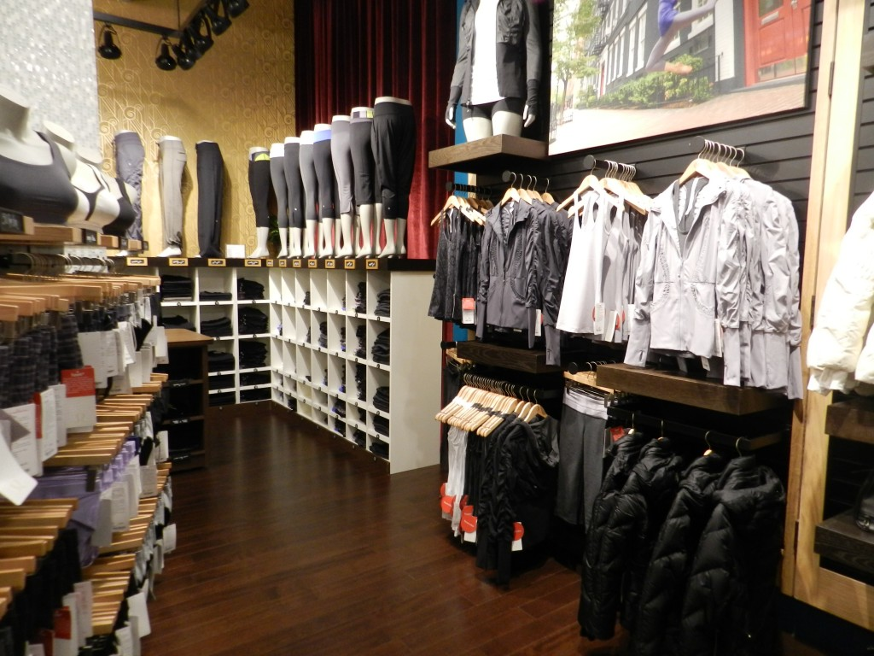
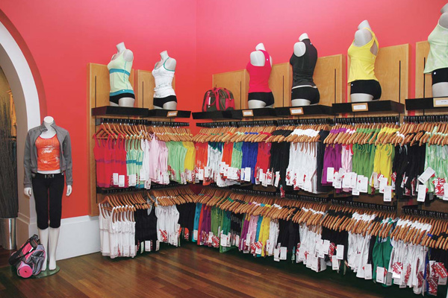
Addendum #2, Flesh Décor
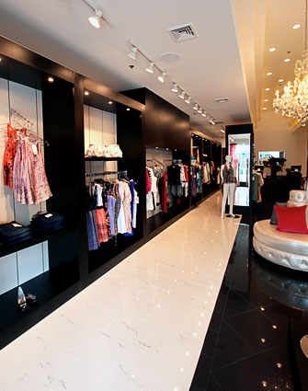
Addendum #3, Lululemon Symbol
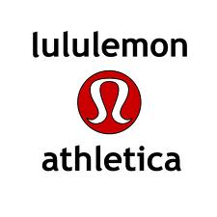
Addendum #4. Basic Products
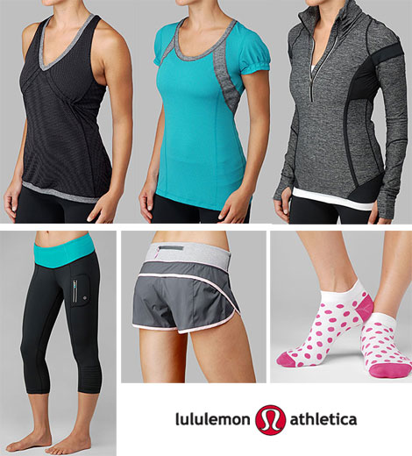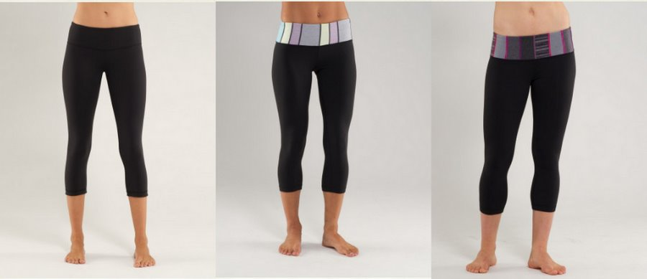
Addendum #5, Fashion products

